Securing Computer Folders With Rijndael Security Extension And Your Bluetooth Enabled Mobile Phone
Krishna Kumar Singh, Aanchal Gupta, Firoj Khan, Aman Singh.

Department Of Computer Science And Engineering, Dr.APJ Abdul Kalam University, Moradabad Institute Of Technology, Moradabad.

Abstract
In present day, the increasing reliance on computer systems has led to the dependence on confidential security measures. Various methods used to identify a user are Digital signature, Challenge-Response, Biometrics, IPSec (Internet Protocol Security), Single- Sign On and Password. Password has become one of the most ubiquitous modern day security tool and is very commonly used for authentication. These passwords are string of characters used for authentication or user access. Unfortunately users set passwords that can be easily memorized, in turn increasing threats. Password meters indicating password strength are used to increase effectiveness of passwords and make them less predictable. Biometrics on the other hand requires the assumption of unrealistic preconditions for performance gain. Access control systems require time-trusted and reliable personal recognition. To overcome the problems faced by these processes individually, we can use a combination of two or more security processes. Two-factor authentication has ameliorated security in authentication systems. Sensitive files can be provided double protection using Rijndael security extension and Mobile Bluetooth tokens. This paper will mainly compare various authentication methods and present the improvement in windows password policies using a combination of mobile Bluetooth and Rijndael encryption.
File Security is a feature of your file system which controls which users can access which files, and places limitations on what users can do to files. The file system considers the user’s identity, and what kind of action the user is performing, and consults the file’s permissions.
Advanced Encryption Standard(AES) is based on a design principle known as a substitution-permutation network, and is fast in both software and hardware. Unlike its predecessor Data Encryption Standard(DES), AES does not use a Feistel network. AES is a variant of Rijndael which has a fixed block size of 128 bits, and a key size of 128, 192, or 256 bits. By contrast, the Rijndael specification is specified with block and key sizes that may be any multiple of 32 bits, both with a minimum of 128 and a maximum of 256 bits.

Keywords: Bluetooth, Rijndael, protection, computer, folders, two, factor, authentication, security

- Introduction
Nowadays, Security of the computer files and folders have been a core issue ever since the advent of the windows. Passwords were then introduced to solve this issue but they themselves lend a host of disadvantages. In this paper, we shall study what disadvantages the passwords bring and how we can tackle them. Also we shall propose a Two Factor Authentication [T-FA] system utilizing Bluetooth as a factor coupled with the powerful Rijndael Encryption Algorithm. Bluetooth is the most commonly used technology for Point to Point short range of communication of devices. Besides from being

commonly used, it also offers multi connection. Rijndael algorithm is an Advanced Encryption standard, believed to be the most effective encryption and decryption cryptographic algorithm. Its minimum 10 rounds of encryption and variable key size with a minimum of 128 bits makes it difficult to crack. Coupling the widespread accessibility of Bluetooth and powerful encryption of Rijndael, a Two Factor Authentication System [T-FA] can be created which will not only efface the disadvantages of passwords, but also create a user friendly security system.

2. Existing Systems

Although passwords are usually considered in terms of authentication for a service or a device, today they are encountered in many other ways in the workplace – and existing password policies do not cover these. As a result, users adopt ad-hoc solutions, which are usually insecure. (Philip Inglesant & M. Angela Sasse et al, 2010)

2.1 Password security in windows The password feature is interlinked with windows user accounts. Userspossessing administrator privileges can create,
modify and delete accounts. In order to judge the strength of passwords, password policies came into existence. This characteristic has been a vital issue in the windows system. Keyloggers or keystroke logging malware can be effectively protected with the help of password managers.
However, these managers cannot fight man-in-the-browser attacks. A major benefit of passwords is that they are portable and stateless.
.

Passwords face several flaws corresponding to bookmarklet, authorization, web and user interfaces. A bookmarklet is a bookmark stored in a web browser that holds JavaScript commands to stretch the browser's functionality. Although biometrics and security tokens are some of the alternatives to passwords, they increase the overall risk theft, privacy threat and rise in infrastructural costs.

Elizabeth Stobert in her paper explains the password life cycle with the help of following diagram:
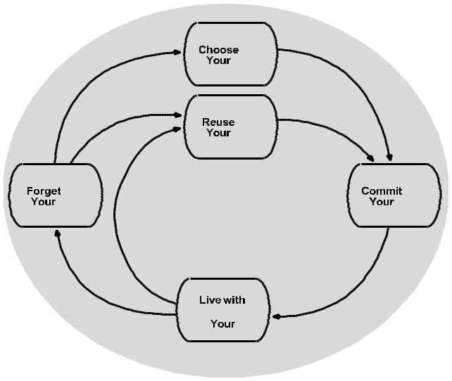

Fig. 1 The password life cycle (Elizabeth Stobert et al, 2014)

The length of passwords plays an important role in determining its strength. Success on brute force attack mainly depends on the length of passwords. Generally, brute force attack fails in case of long passwords. Passwords containing alphanumeric characters are another type of strong passwords. Password disclosure should be avoided in order to prevent social engineering attacks.

2.2 Vulnerabilities

There are many reasons due to which password is considered as a weak form of protection. Passwords are user-dependent in network security chain. Users often do not take security procedures for password seriously. This leads to vulnerabilities in passwords.

Major problems faced by passwords are follows:
- Noting down of difficult passwords
- Periodic change of passwords

- Using dictionary words as passwords

- Personal information. Example: Username, initials etc.

- Use of default passwords. Example: password
- Double words
- Reverse words
- Mixed case dictionary

3. Solutions to Password Vulnerabilities

Vulnerability is an imperfection in the system which can be victimized by the intruder to weaken the

system. This imperfection may be present in design, implementation or maintenance of the system. We can easily block threats if we establish control over the vulnerability. Various kinds of vulnerabilities exist in the password protection system. Synthesizing a strong password and generating a high extremity on the frequency of guesses to minify cracking. Stronger policies could also be implemented using Single Sign-On. The load on user shrinks with the help stronger passwords. Opportunistic misuse of unattended desktops can be palliated with the help of screen locks and time-out. Password expiry and prevention of recently used passwords also helps reduce the attack on passwords. Different problems faced by passwords have different solutions. To overcome this two factor authentication is used. It provides single solution to all the problems faced by passwords.

4. Two Factor Authentication

The introduction of the Two Factor Authentication has been done in order to heighten the Authentication Systems. The overall access to a System is not defined by a single factor, like password, but the combination of multiple factors. In order to potentiate the security of access control systems, two factor authentication (T-FA) comes in very handy mainly because it focusses on combination of both factors. Christian Rathgeb says in his research, “These factors include, passwords, representing ‘something you know’, or physical tokens, such as smart-cards, representing ‘something you have’. Additionally, biometric traits are applied, representing ‘something you are’”. (Christian Rathgeb et a l, 2010).
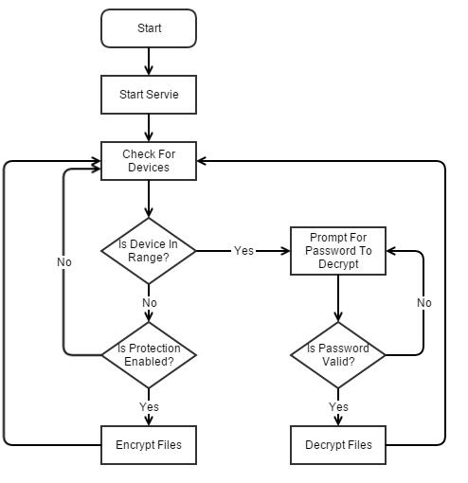

Fig. 2 Windows Service

Popular examples are ATM, Biometrics, etc.

5. Bluetooth in Two Factor Authentication

Bluetooth, a wireless technology for the transmission of data among two devices in close propinquity of each other has veritably changed the world. The connection between two devices are absolutely battened as they

operate on Personal Area Network(PAN).The major advantage that Bluetooth offers for T-FA is its range of network which is just 100 meters and is enough to personify an authenticated user’s presence. Bluetooth is a Radio Frequency (RF) specification for short range voice and data transfer, whether it be point-to-point or point to multiple points. Bluetooth will empower the users to connect to a wide range of computing and telecommunications devices without the need for proprietary cables that often fall short in terms of ease-of-use. The technology constitutes an opportunity for the industry to deliver wireless solutions that are ubiquitous across a broad range of devices. The strength and direction of the underlying Bluetooth standard will ensure that all solutions meet stringent expectations for ease-of-use and interoperability (Smart Handheld Group). Bluetooth is unremarkably used in Mobile Phone Market. Almost every phone presently contains Bluetooth in it which makes it a very cost effective T-FA Authenticator. The operational terms of Bluetooth in terms of processing power and battery is also very minimalistic. Bluetooth can conduce in the T-FA System in the following manner: Authentication: Connect to a particular device only if the device is known to the system, otherwise abort connection. The familiarity of Bluetooth device is ascertained by the MAC Address of the device. Authorization: Only authorized Bluetooth devices should have the access to the protected data. Confidentiality: Since Bluetooth devices have a range of only 100 meters, there won’t be any spoofing since as soon as the device is out of range, the protected personal files and folder would be encrypted.
6. Rijndael Algorithm
Rijndael Algorithm, A Cryptographic Algorithm, is widely conceived as one of the best algorithms for encryption. Efficient implementation of the algorithm is due to the chasteness of its design which makes the effectuation easy to understand. Joan Daemen in his paper says that “ It also facilitates understanding the mechanisms that give the algorithm its high resistance against differential cryptanalysis and linear cryptanalysis, to date the most important general methods of cryptanalysis in symmetric cryptography”. (Joan Daemen & Vincent Rijmen et al, 2010
6.1 AES Encryption
Encryption is a popular techniques that plays a major role to protect data from intruders. AES algorithm uses a particular structure to encrypt data to provide the best security. To do that it relies on a number of rounds and inside each round comprise of four sub-process. Each round consists of the following four steps to encrypt 128 bit block.
a) Add Round Key
AddRoundKey is the most vital stage in AES algorithm. Both the key and the input data (also referred to as the state) are structured in a 4x4 matrix of bytes [19]. Fig.6 shows how the 128-bit key and input data are distributed into the byte matrices. AddRoundKey has the ability to provide much more security during encrypting data. This operation is based on creating the relationship between the key and the cipher text. The cipher text is coming from the previous stage. The AddRoundKey output exactly relies on the key that is indicated by users [15]. Furthermore, in the stage the subkey is also used and combined with state. The main key is used to derive the subkey in each round by using Rijndael's key schedule. The size of subkey and state is the same. The subkey is added by combining each byte of the state with the corresponding byte of the subkey using bitwise XOR [16].
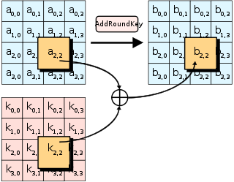

b) Shift Row
The next step after SubByte that perform on the state is ShiftRow. The main idea behind this step is to shift bytes of the state cyclically to the left in each row rather than row number zero. In this process the bytes of row number zero remains and does not carry out any permutation. In the first row only one byte is shifted circular to left. The second row is shifted two bytes to the left. The last row is shifted three bytes to the left [13]. The size of new state is not changed that remains as the same original size 16 bytes but shifted the position of the bytes in state as illustrated
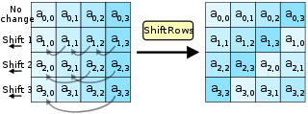
c) Sub Bytes
The first stage of each round starts with SubBytes transformation. This stage is depends on nonlinear S-box to substitute a byte in the state to another byte. According to diffusion and confusion Shannon’s principles for cryptographic algorithm design it has important roles to obtain much more security [12]. For example in AES if we have hexa 53 in the state, it has to replace to hexa ED. ED created from the intersection of 5 and 3. For remaining bytes of the state have to perform this operations.
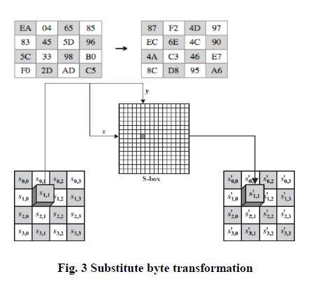

d) Mix Column
Another crucial step occurs of the state is MixColumn. The multiplication is carried out of the state. Each byte of one row in matrix transformation multiply by each value (byte) of the state column. In another word, each row of matrix transformation must multiply by each column of the state. The results of these multiplication are used with XOR to produce a new four bytes for the next state. In this step the size of state is not changed that remained as the original size 4x4 as shown in Fig. 5.
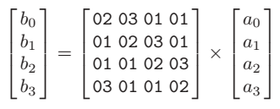6.2 AES Decryption
The decryption is the process to obtain the original data that was encrypted. This process is based on the key that was received from the sender Cryptography and Network Security 2017 of the data. The decryption processes of an AES is similar to the encryption process in the reverse order and both sender and receiver have the same key to encrypt and decrypt data. The last round of a decryption stage consists of three stages such as InvShiftRows, InvSubBytes, and AddRoundKey as illustrated

a)Inverse Add Round Key – Performs XOR operation between the cipher text and intermediate expanded key corresponding to that particular iteration. E.g., if the diagrams on the left represent the cipher and the key values, the final value after it has generated by this step is shown on the right.

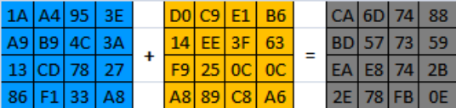

b) Inverse Shift Row – This step rotates each ith row by i elements right wise, as shown in the figure.

CA 6D 74 88 CA 6D 74 88
BD 57 73 59 59 BD 57 73
EA E8 74 2B 74 2B EA E8
2E 78 FB 0E 78 FB 0E 2E

c) Inverse Sub Bytes – This step replaces each entry in the matrix from the corresponding entry in the inverse S-Box[2] as shown in figure.

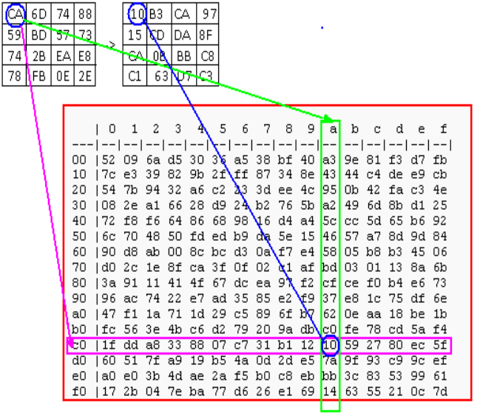
d) Inverse Mix Column - The Inverse MixColumns[3] operation performed by the Rijndael cipher, along with the shift-rows step, is the primary source of all the 10 rounds of diffusion in Rijndael. Each column is treated as a polynomial over Galois Field (28) and is
then multiplied modulo x4 + 1 with a fixed inverse
polynomial is c−1(x) = 11x3 + 13x2 + 9x + 14. The
Multiplication is done as shown below.
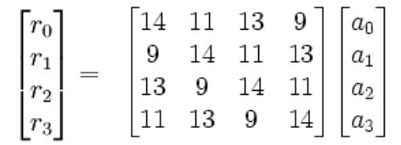
As shown in the block level diagram below, the AES decrypto initially performs key-expansion on the 128- bit key block. Then the round key signals the start of the actual decryption process once the data process is ready. It starts by executing an inverse add round key between cipher text with the modified key (generated in the last iteration of the encryption process) from key expansion. After this step, the AES decrypto repeats the inverse shift row, inverse sub, inverse add round key, and inverse mix column steps nine times. At the last iteration, it does an inverse shift row, inverse sub bytes and inverse add round key to generate the original data.

7. Proposed System

Rijndael Cipher is an Advanced Encryption Standard (AES) based on design principle grounded as

substitution permutation network and is quick in both software and hardware. Avoidance of the Fiestal network in the AES is its important characteristic. AES, a variant of Rijndael has a fixed block size of 128 bits and a key size of 128, 192 or 256 bits. The key size specifies the total number of rounds for conversion of plaintext to ciphertext. They are,

- 10 rounds for 128 bit keys
- 12 rounds for 192 bit keys
- 14 rounds for 256 bit keys

There are 4 processes in each round namely,

- Sub Bytes Transformation
- Shift Rows Transformation
- Mix Column Transformation
- Add Round Key (Zahir Zainuddin et al, 2013)

This research focuses on Two Factor Authentication [T-FA] system introducing the use of mobile phones tokens employing Bluetooth and Rijndael Encryption. The following is the basic thought of this research.

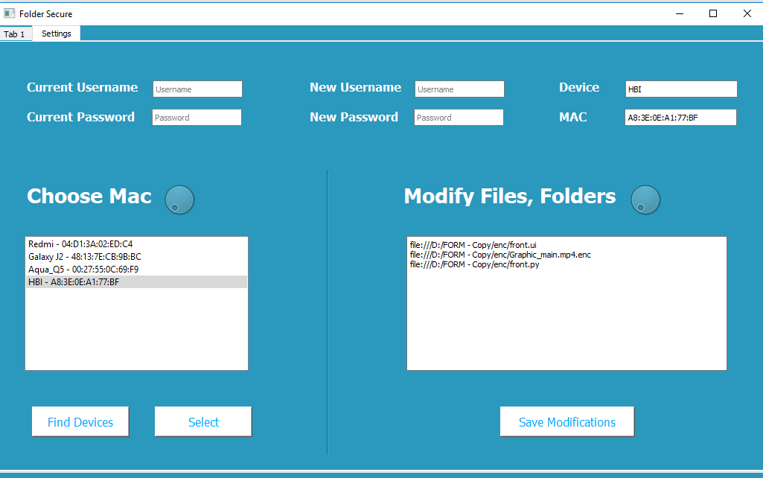

Fig. 4 System Design

Bluetooth is enabled in your laptop or PC. An interface is written to discover the Bluetooth devices by their MAC address and the same is authenticated with the Admin password. Registry of system stores the MAC address. Application is initiated as a background process along with the PC. The folder in which the user is currently working on is selected in the configuration mode. A Handshake protocol is implemented by the program every 5 seconds so that whenever the authenticated Bluetooth device moves away from the PC, all the working files and folders are encrypted and account is logged off. After a successful log in, the program will search for the authenticated Bluetooth device and prompt for the password. Successful password matching then decrypts all the files and folders user was working on. In case of mismatch of Bluetooth devices, the application never demands for the password.

Conclusion

This application program would ensure user authentication by the windows password login further authentication to most private files employing their Bluetooth enabled mobile phones. This can lead to less frequent password changes or have less stringent policies that the users are resistant to and they can and furnish an extra feature that would permit for an automated environment employing the proximity sensor to assert if your mobile token is in range or not.

Acknowledgment

I express my deepest sense of gratitude towards my guide Ms. Kanchan Assistant Professor, department of Computer Science Engineering, Moradabad Institute of Technology, Moradabad for his/her patience, inspiration, guidance, constant encouragement, moral support, keen interest and valuable suggestion during preparation of this project report. My heartfelt gratitude goes to all my faculty members of computer science engineering deptt. Who with their encouraging and caring words and most valuable suggestions have contributed, directly and indirectly, in a significant way towards completion of this project report. I am indebted to all my classmates for taking interest in discussing my problem and encouraging me. I owe a debt of gratitude to my father and mother for their consistent support, sacrifice, candid views, and meaningful suggestion given to me at different stages of this work.Last but not the least I am thankful to the almighty who gave me the strength and heath for completing my report.

References

Securing Computer Folders using Bluetooth and Rijndael Encryption by Nikita Saple, Dhanraj Poojari, Ankita Kesarkar and Alka Srivastava
International Journal of Current Engineering and Technology
http://inpressco.com/category/ijcet
www.google.com
Resources page of Inno-Logic. [Online]. Available: http://www.inno-logic.com/resources/17.php

